Online Registration
- In your internet web browser please go to https://my.ccbc.edu/
- Once on the site please login with your firstname.lastname and your CCBC password.
- Scroll down to Course Schedules and click on the Add/Drop Courses link.
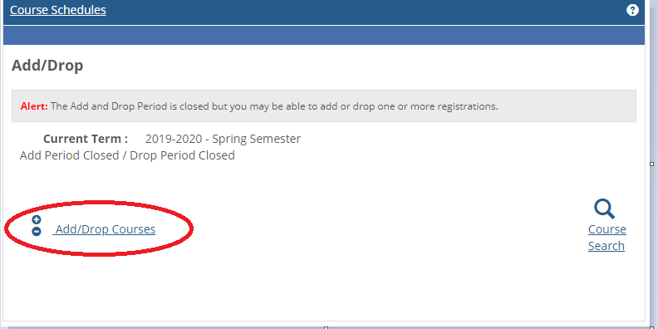

- On the top of the screen select the term you wish to enroll in. For this example the 2020-2021 – Fall Semester is selected. You may fill out the rest of the search criteria but it is not necessary.
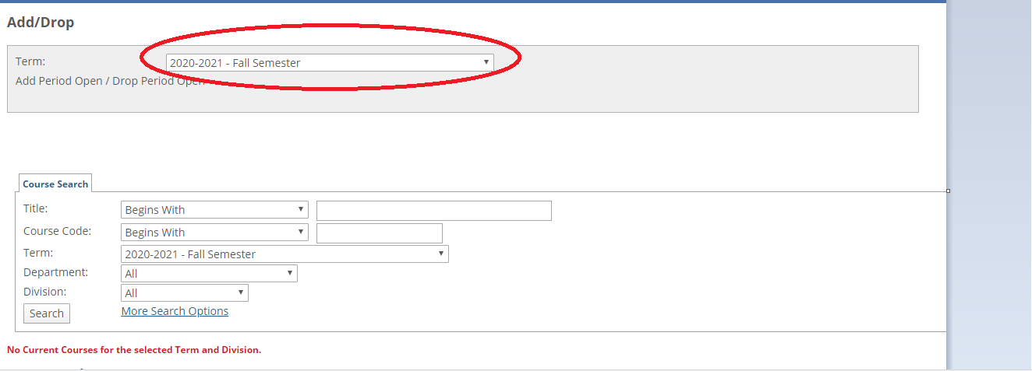

- Next you can add the course(s) by selecting the check box where it says Add and to read more about the course you can select the course code name to read more information on the course. AVIC 235 02 will not let you add the course in the picture below because requirements are not met.

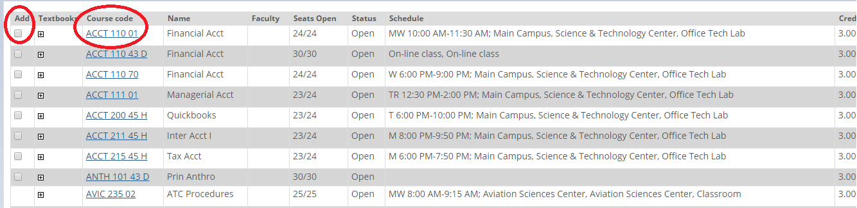
- Once you have selected your courses select Add Courses.
- Next you may drop a course by selecting by selecting the check box by the course(s) you would like to drop then select Drop courses to finish. Once you are ready to pay select My Account Info on the bottom of the screen.
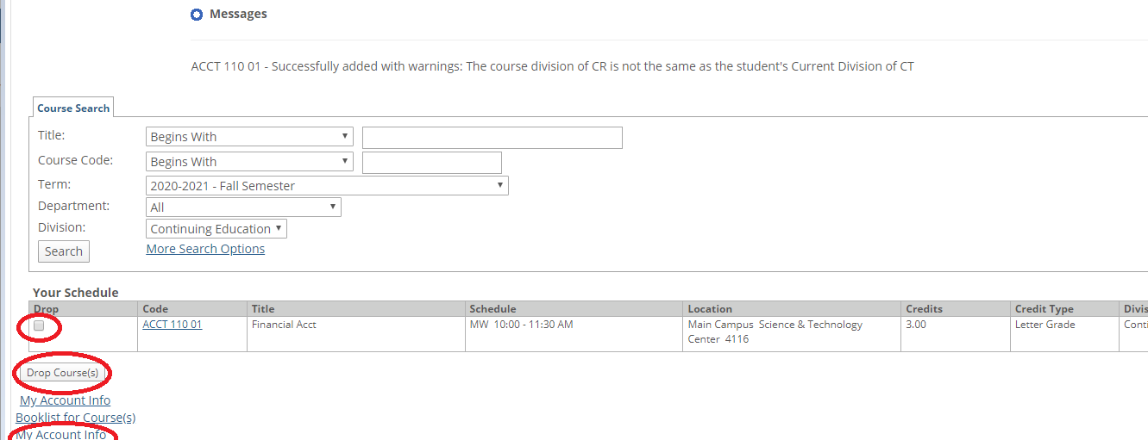
- On this page you would select My Account Balances and next select View Account details and history.
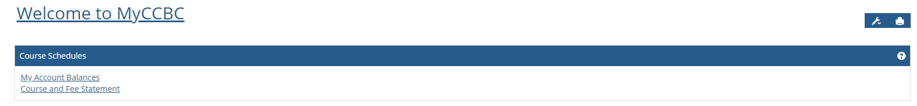
- Finally select Make a Payment to pay tuition online.
